**Quotes Generator App Using Streamlit**

**By**

**Arit Kar(MST03-0071)**

**Submitted to Scifor Technologies**

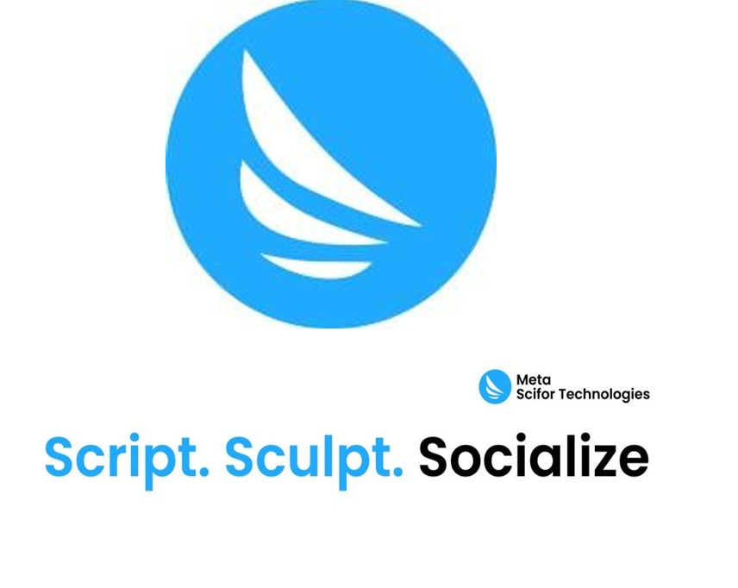

**UNDER GUIDIANCE OF Urooj Khan**

**TABLE OF CONTENTS**

* Abstract 03
* Introduction 04
* Technology Used 05
* Methodology 06-07
* Code Snippet 08-10
* Streamlit Interface 11
* Results and Discussion 12
* Conclusion 13
* References 14

**ABSTRACT**

This project involves the development of a web application that scrapes inspirational quotes from a website based on user-selected topics and provides an option to download the quotes in a CSV file. The app is built using Streamlit, leveraging the simplicity of Python for both web scraping and data processing. BeautifulSoup is used for parsing HTML content, while Pandas handles data manipulation and CSV file generation. The project highlights the integration of web scraping with a user-friendly interface, making it accessible for users to interact and extract meaningful content.

**INTRODUCTION**

**Background**

Inspirational quotes are a popular form of content shared across various platforms, providing motivation and encouragement. Automating the process of collecting these quotes from a website not only saves time but also allows users to curate quotes based on specific themes. This project aims to create a Streamlit app that does just that.

**Objective**

The objective of this project is to build a web-based application that scrapes quotes from a website and allows users to download them in a structured format. The app's simplicity ensures ease of use, while the underlying code handles complex tasks like data scraping and file generation.

**TECHNOLOGY USED**

**Programming Language**

* **Python**: The primary language used due to its powerful libraries for web scraping, data manipulation, and web app development.

**Libraries and Frameworks**

* **Streamlit**: A framework for creating web applications in Python. It is used here to build the interface.
* **Requests**: Used to send HTTP requests to retrieve web pages.
* **BeautifulSoup**: A library for parsing HTML and extracting data from web pages.
* **Pandas**: Used for data manipulation and CSV file generation.

**Development Environment**

* **Streamlit Cloud**: For deployment and testing of the web application.

**METHODOLOGY**

**Web Scraping**

The application retrieves quotes from the website [quotes.toscrape.com](https://quotes.toscrape.com) based on the topic selected by the user. The scraping process involves sending a request to the webpage, parsing the HTML content using BeautifulSoup, and extracting the required data, such as quote text, author name, and a link to the author's profile.

**User Interface**

The app provides an interactive interface where users can:

* **Select a Topic**: A dropdown menu allows users to choose a topic.
* **Generate Quotes**: Quotes related to the selected topic are displayed along with author details.
* **Download CSV**: Users can download the displayed quotes as a CSV file.

**CSV File Generation**

The app converts the scraped data into a Pandas DataFrame and generates a CSV file with columns for the quote, author, and link. The file is encoded in cp1252 to ensure compatibility with most spreadsheet applications.

**CODE SNIPPET**

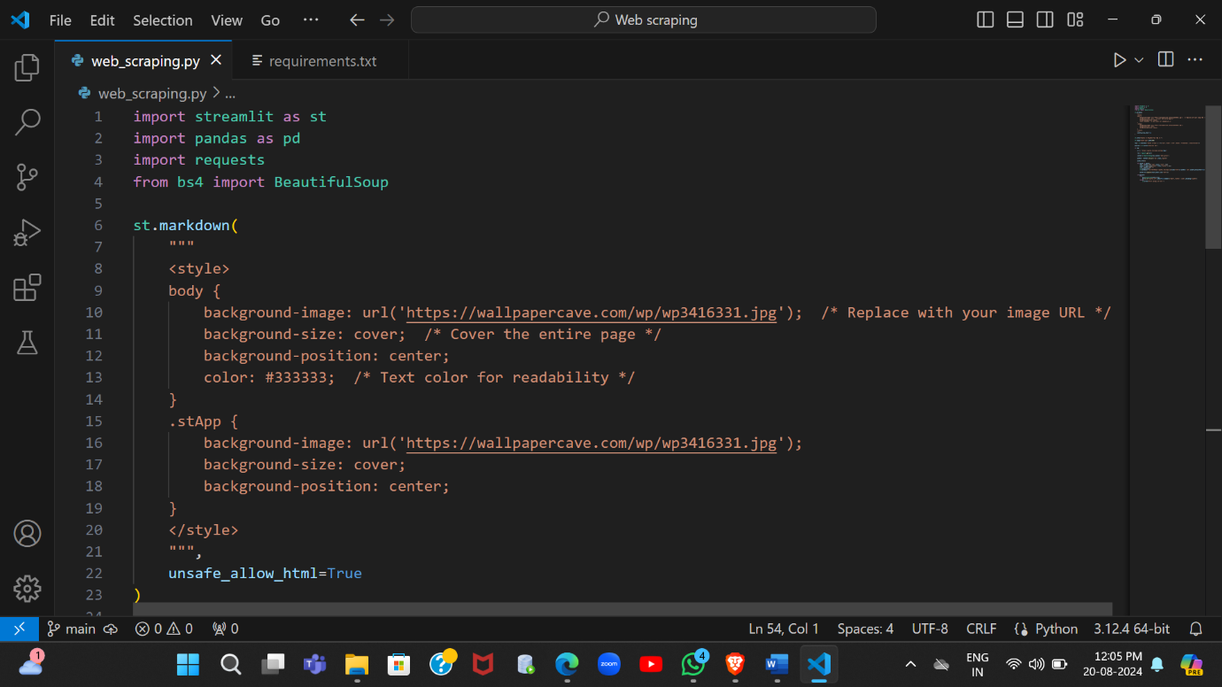

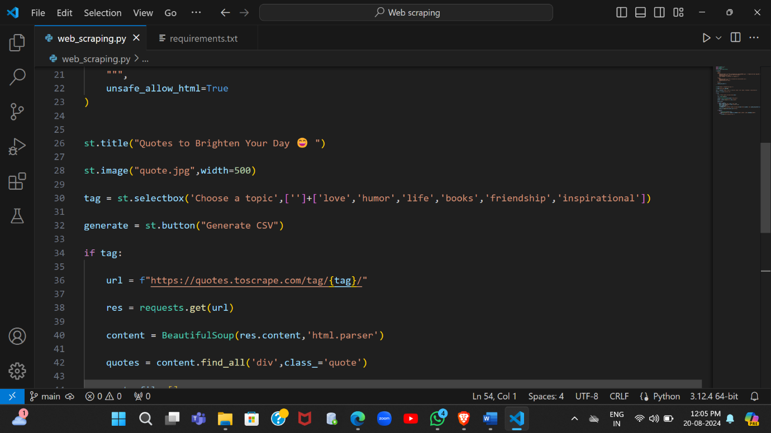

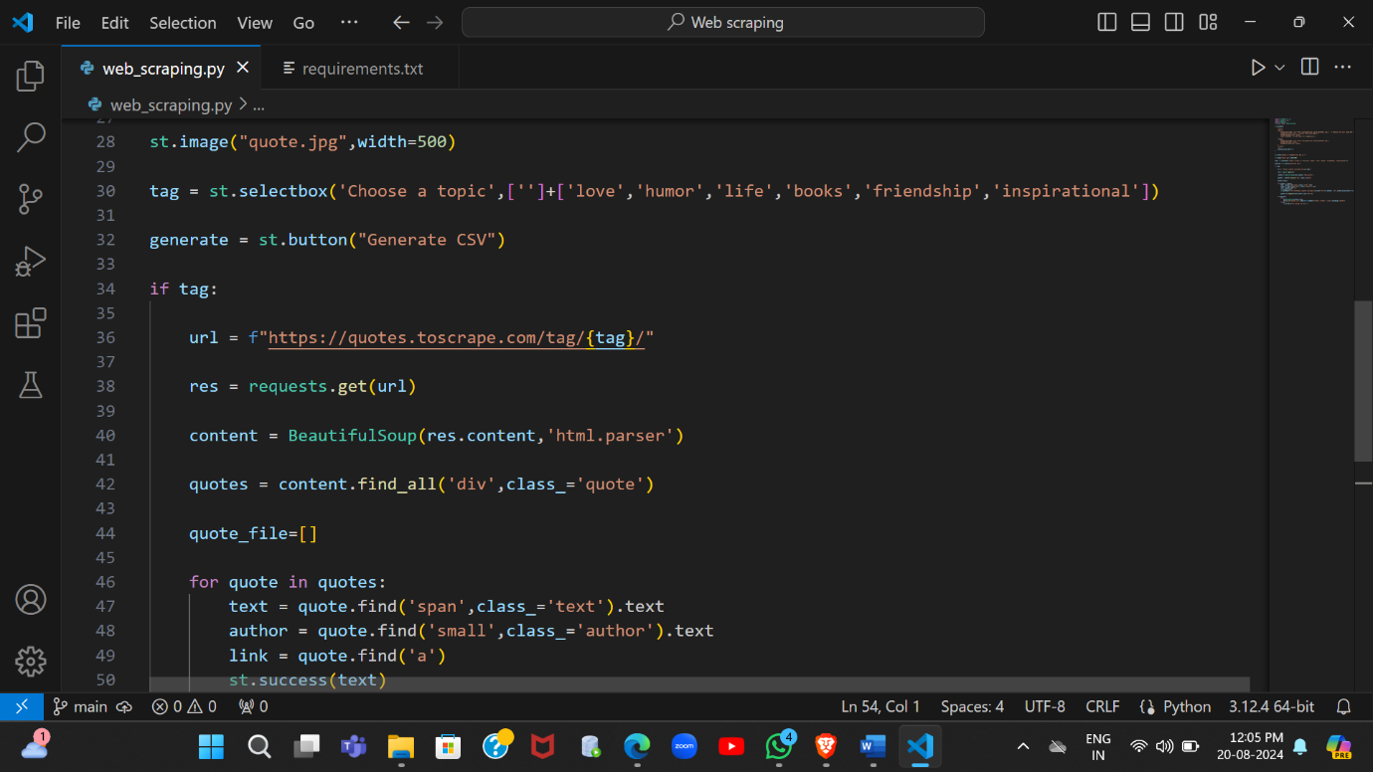

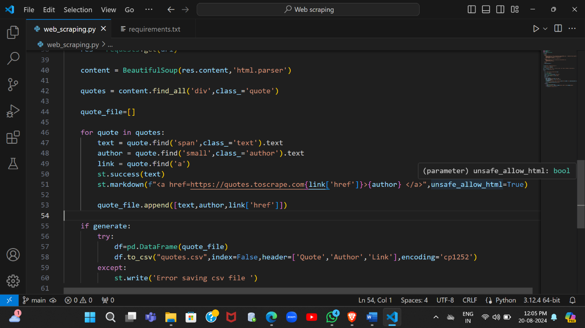

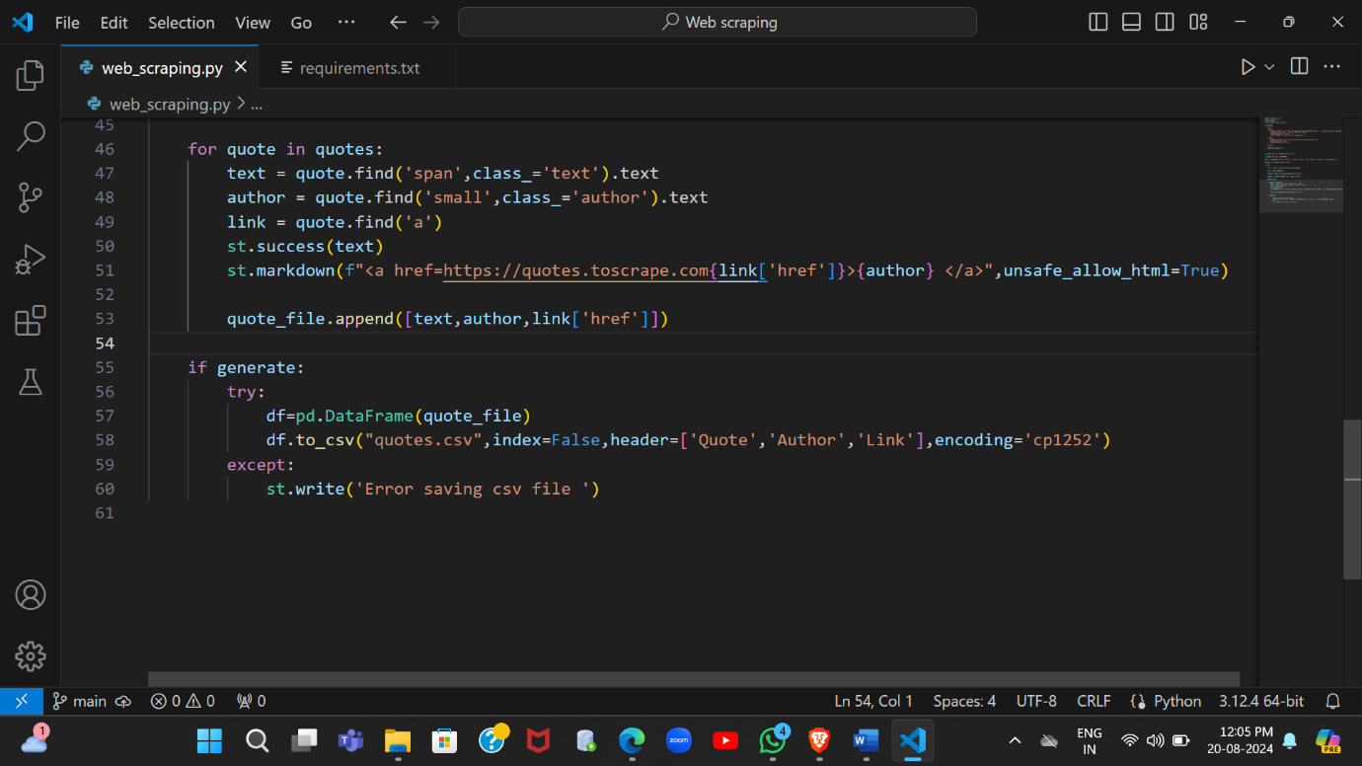

**STREAMLIT INTERFACE**

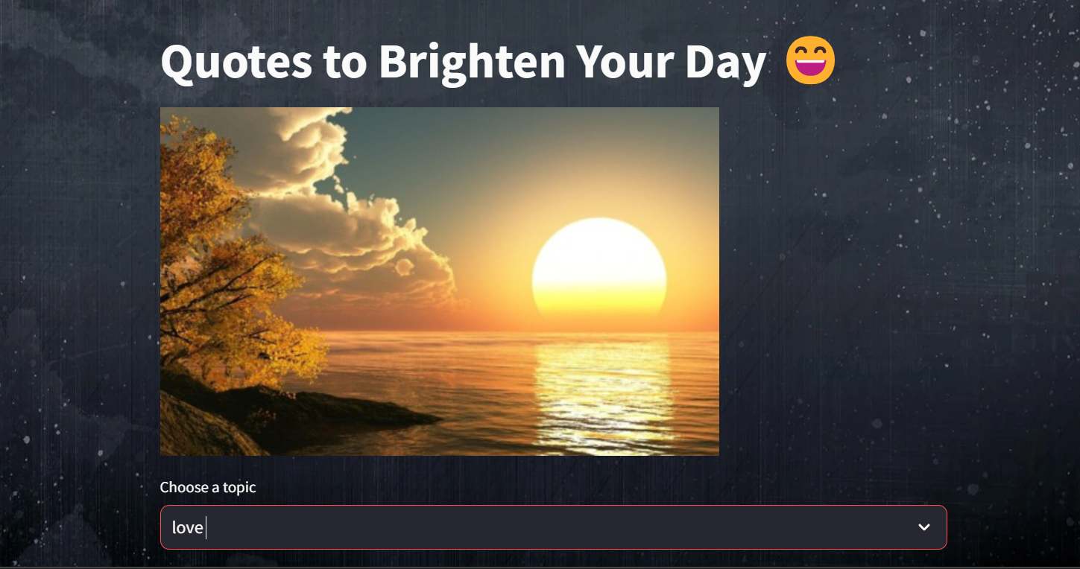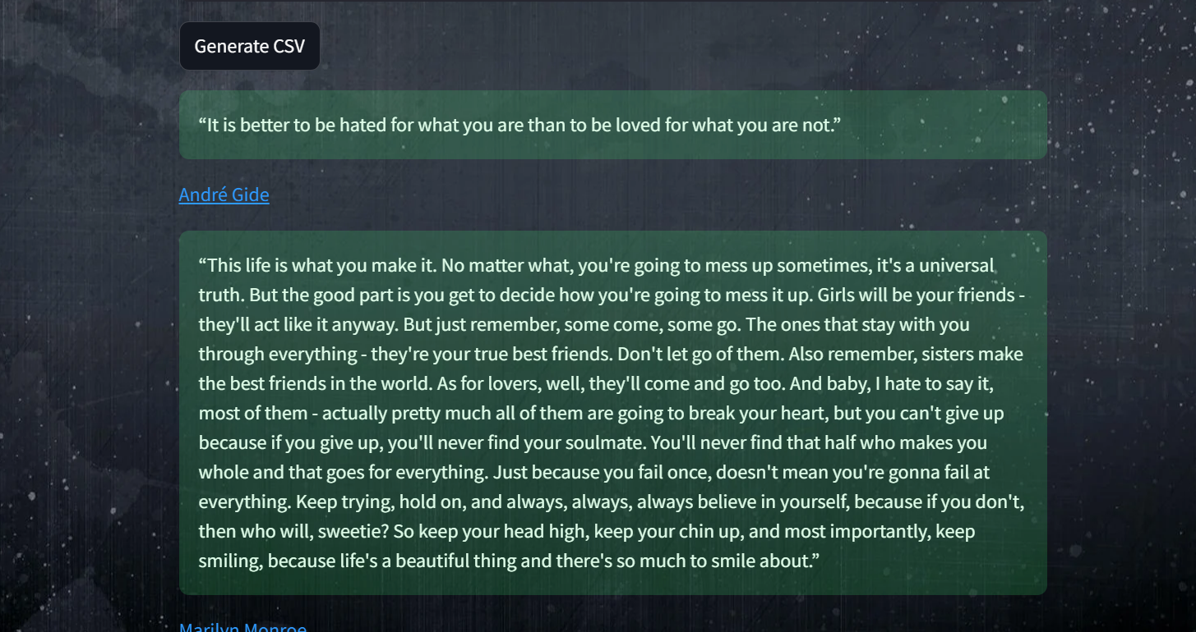

**RESULTS AND DISCUSSION**

The app successfully scrapes quotes based on the selected topic and displays them in the Streamlit interface. The "Generate CSV" feature allows users to download a structured CSV file, which can be opened in any spreadsheet application. The user interface is intuitive, and the backend handles data scraping efficiently, making the app responsive and user-friendly.

**CONCLUSION**

**Summary**

This project demonstrates the successful integration of web scraping and data processing within a Streamlit application. The Quotes Generator App is a useful tool for anyone looking to collect inspirational quotes on specific topics. It simplifies the process of gathering and organizing quotes, making it accessible to a wide range of users.

**Future Work**

* **Expand Topics**: Include more topics for users to choose from.
* **Pagination**: Implement pagination to load more quotes.
* **Search Feature**: Add a search bar for users to find quotes by specific keywords.

**REFERENCES**

* [quotes.toscrape.com](https://quotes.toscrape.com)
* Python Documentation
* Streamlit Documentation